Задание для 3-6 классов.
Task 1
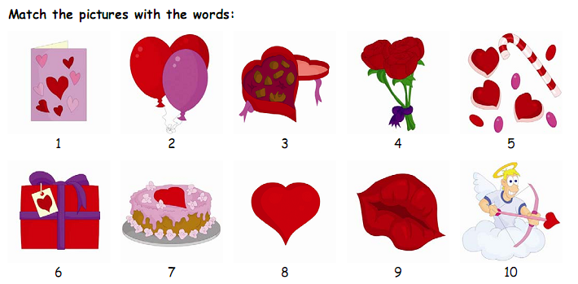

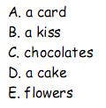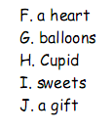

Task 2
Match the words.
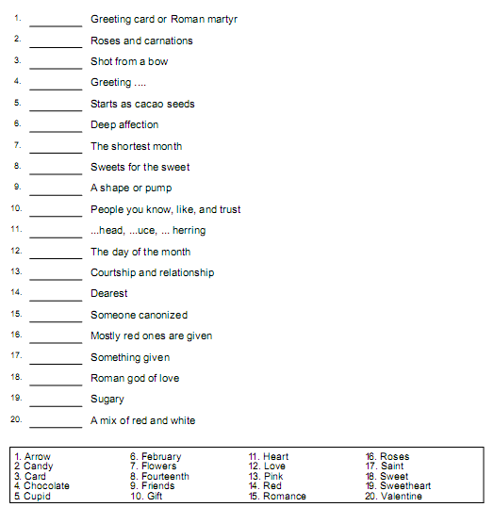

Task 3
1. St. Valentine’s Day is celebrated on the…
a) March, 8
b) January, 1
c) February, 14
2. Valentine was…
a) a king
b) a priest
c) God of Love
3. St. Valentine’s Day is a holiday of …
a) lovers
b) teachers
c) soldiers
4. Valentine’s cards have a shape of …
a) star
b) flower
c) heart
5. The symbol of St. Valentine’s Day is …
a) heart
b) red rose
c) girl
6. Valentine fell in love with the …
a) jailer’s daughter
b) queen
c) nurse
7. Valentine wrote his lover a letter and signed it …
a) “to my sweetheart”
b) “from your Valentine”
c) “Love”
8. When did the tradition of sending written valentines to loved ones begin?
a) AD 270
b) Around the year 1400
c) 1840

